TO-BE Doccuments Executive Summary
This document presents the TO-BE (Future State) process mappings for 7 priority government ministries. Each process has been redesigned to incorporate:

BPMN 2.0 Legend

Symbol | Element | Description
((○)) | Start Event | Process begins
((●)) | End Event | Process ends
[Task] | Task/Activity | Process step
[NEW: Task] | New Task | NEW automated/integrated step
{X} | Exclusive Gateway | Decision - ONE path only
--> | Sequence Flow | Normal flow
-.-> | Loop Back | Return to previous step
style fill:#90EE90 | Highlighted | New TO-BE steps (green)

- Children Services (CRS Integration)
Ministry: Ministry of Labour and Social Protection
Department: State Department for Social Protection

Transformation Overview

AS-IS | TO-BE | Change
Manual child info entry | CRS auto-lookup | Automated
Paper-based history check | CRS integrated history | Integrated
Manual documentation | Pre-populated forms | Simplified

  - Reporting Process (TO-BE)
Key Change: CRS integration replaces manual "Document Child Info" step


DETECTION
○
CRS INTEGRATION - NE
ASSIGNMENT
●
Auto-Populate Child Record
Query CRS for Child Info
Record Details
Create Case File
Assign Officer
Assign Reference

Process Steps:

    - Record Details
    - NEW: Query CRS for Child Info
    - NEW: Auto-Populate Child Record
    - Assign Reference
    - Assign Officer
    - Create Case File

  - Intake Assessment (TO-BE)
Key Change: CRS Lookup added for comprehensive history retrieval

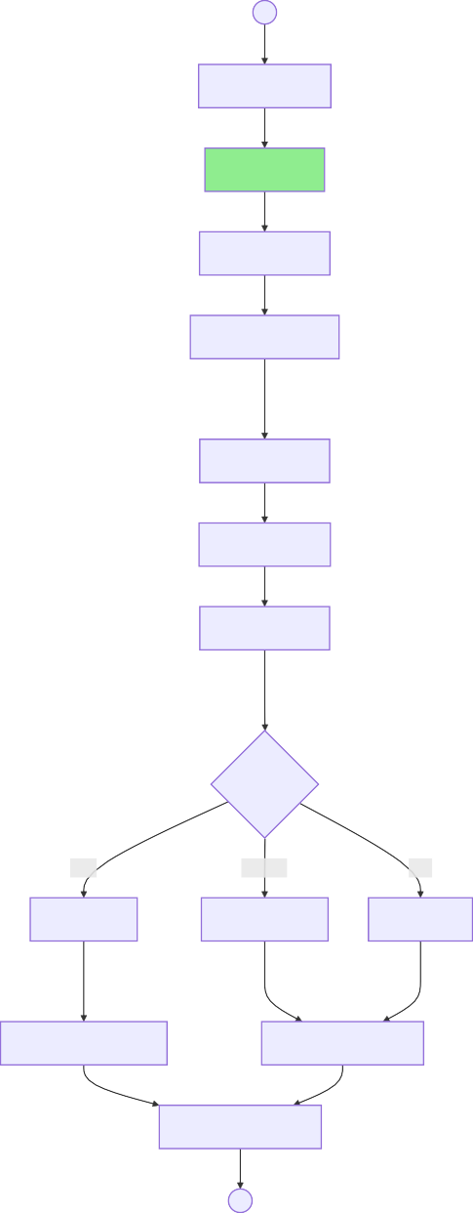
SCREENIN
○
Review Report
CRS Lookup
Check History
Contact Reporter
DECISION
Risk Level?
High
Medium
Low
HIGH Risk
MEDIUM Risk
LOW Risk
ACTION
Emergency Removal
Standard Response
Document Decision
●
RISK ASSESSMEN

Assess Safety

Evaluate Risks

Assess Family

  - End-to-End Child Protection (TO-BE)

○
Case Registered
CRS Lookup
Risk Assessment
Home Visit
END-TO-END CHILD PROTECTION - TO-BE
Evidence
Care Plan
Conference
Intervention
Reviews
Archive
●

Civil Registration Services (IPRS/CRS Integration)
Ministry: Ministry of Interior and National Administration
Department: Department of Civil Registration Services

Transformation Overview

AS-IS | TO-BE | Change
Attach Marriage Certificate | CRS auto-retrieval | Attachment REMOVED
Manual parent verification | IPRS auto-lookup | Automated
Attach Death Certificate | IPRS auto-retrieval | Attachment REMOVED
Manual ID verification | IPRS query | Automated

  - Birth Registration - Timely (TO-BE)

Key Changes:

Marriage certificate attachment REMOVED IPRS/CRS auto-verification added
- NEW
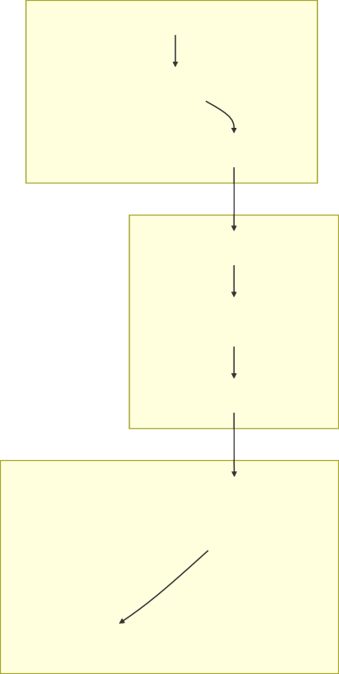
APPLICATION
○
IPRS/CRS INTEGRATION
VERIFICATIO
Auto-Verified?
REGISTRATIO
ISSUANCE
●

Registrar Signs

Assign Entry Number

Key into Register

Issue Certificate

Print Certificate

Process Payment

Flag for Manual Review
Match
Mismatch

Auto-Verify Details

Retrieve Marriage Record from CRS

Query IPRS for Parents

Provide Parent IDs

Complete Form

Removed Steps:

Attach Parent IDs → Provide ID Numbers only
Attach Marriage Certificate → Auto-retrieved from CRS

  - Birth Registration - Late (TO-BE)
Key Change: IPRS/CRS queries replace manual document verification

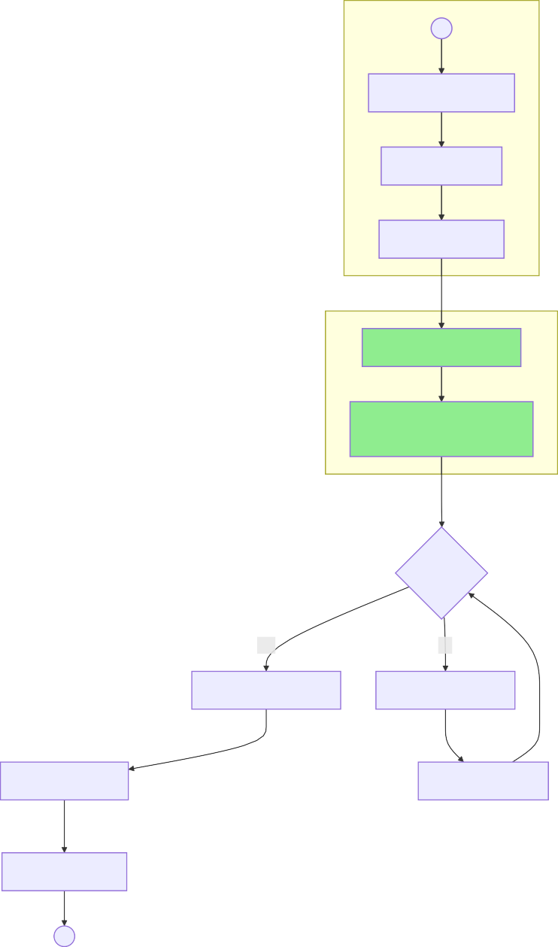
APPLICATION
○
Complete Late Form
Attach Affidavit
Attach Evidence
IPRS/CRS LOOKUP - NE

Query IPRS for Parents
Search CRS Historical
Records
VERIFICATIO
Sufficient?
Yes
No
Approve Registration
Schedule Interview
ISSUANCE

Key into Register
Interview Parents
Issue Certificate
●

  - Death Registration (TO-BE)

Key Changes:

Death certificate attachment REMOVED ID of deceased attachment REMOVED IPRS auto-lookup added

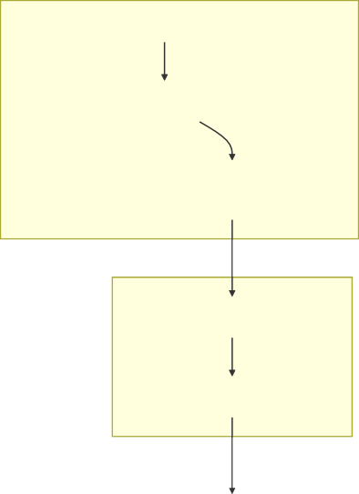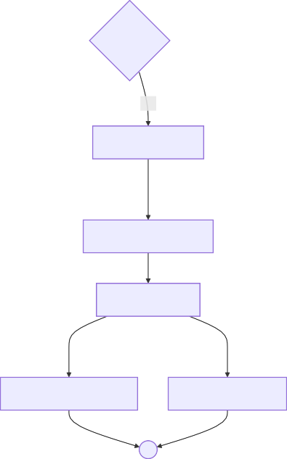
APPLICATION
○
IPRS LOOKUP - NEW
VERIFICATIO
Complete?
No
Yes
Key into Register
ISSUANCE
Issue Death Certificate
Issue Burial Permit
●
Verify Cause
REGISTRATIO

Assign Entry Number

Registrar Signs
Request More Info
Retrieve Death Details
Query IPRS for Deceased
Provide Deceased ID Number
Complete Form

Removed Steps:

Attach Death Certificate → Auto-retrieved
Attach ID of Deceased → Provide ID Number only

  - End-to-End Civil Registration (TO-BE)



END-TO-END CIVIL
REGISTRATION - TO-BE
○
●
Certificate Issuance
Registration
Auto-Verify
IPRS/CRS Looku
Notification

Health (Full KHIE/BHI Implementation)
Ministry: Ministry of Health
Division: Health Information Systems

Transformation Overview

AS-IS | TO-BE | Change
Facility-centric IDs | Biometric Health Identifier (BHI) | Unified
Fragmented records | Shared Health Record (SHR) | Centralized
Manual claims | Auto SHA Claims | Automated
No patient portal | AfyaYangu Portal | New Service

  - Patient Journey with BHI (TO-BE)
Key Change: Complete patient-centric unified health record

IDENTIFICATIO
○
MATCHING
Found?
No
Yes
RECORDS RETRIEVA
ENCOUNTER
UPDATE & NOTIF
●

e-Prescribe

Prior Lab Results

Active Medications

Notify Patient

Auto SHA Claim

Update SHR

Push to KHIE

Record Encounter

Clinical Consultation

View History

Query National SHR

Query Registry

Biometric Scan

Retrieve Existing ID

Enroll New Patient

  - KHIE Architecture (TO-BE)
Key Change: Complete health information exchange ecosystem

DATA SOURCE
○
KHIE COR
REGISTRIE
CONSUMERS
●
Provider Registry
Facility Registry
Shared Health Record
Patient Matching
Data Validation
Message Broker
Laboratories
Pharmacies
Private Facilities
AfyaYangu Portal
Health Analytics
Disease Surveillance
SHA Claims
Patient Registry
FHIR Adapter
Public Hospitals

  - AfyaYangu Patient Portal (TO-BE)
Key Change: Patient self-service portal for health records

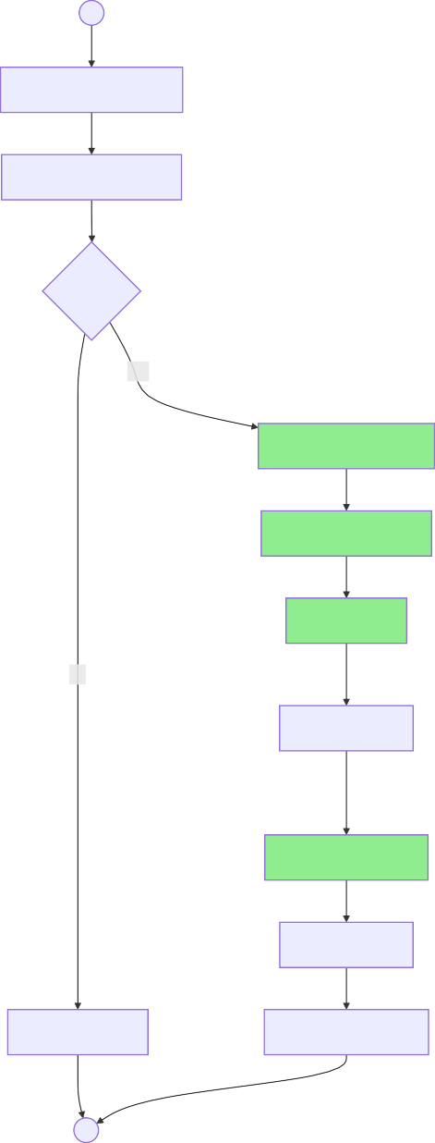
ACCESS
○
Login with National ID
Biometric Verification
Verified?
Yes
DASHBOARD

View Health Records
Prescription History
Lab Results
No
Claims Status
SERVICE

Book Appointment
Request Refill
Access Denied
Download Records
●

  - End-to-End Health Information (TO-BE)

●
View Records
Patient Portal
Submit Claim
Push to SHR
Document Encounter
Treatment
Diagnosis
Consultation
Get Health Record
Query KHIE
Patient Matched
Biometric Scan
○
END-TO-END HEALTH INFORMATION - TO-BE

Education KNQA (Automated Assessment)
Ministry: Ministry of Education
Authority: Kenya National Qualifications Authority

Transformation Overview

AS-IS | TO-BE | Change
Manual certificate verification | Digital verification | Automated
Committee deliberation | AI-assisted assessment | Committee REMOVED
Manual KNQF mapping | Auto-mapping algorithm | Automated
Paper-based RPL | AI-assisted competency matching | Automated

  - Qualification Application (TO-BE)
Key Change: Digital verification replaces manual authentication


NEW
APPLICATION
○
AUTO CHECK - NEW
Complete?
No
Yes
DIGITAL VERIFICATION -
●
Log in System
Return for Completion
Pay Fee
Attach Documents
Forward for Auto- Assessment
Validate Transcripts
Fraud Detection Algorithm
Query Institution Database
Digital Certificate Verification
Auto-Check Completeness
Submit Application

  - Automated Assessment (TO-BE)
Key Change: Committee REMOVED - AI-assisted auto-assessment

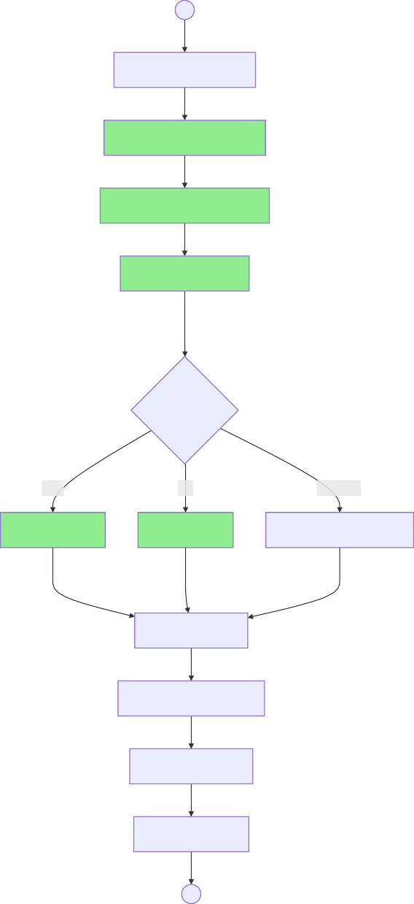
AUTOMATED
ASSESSM○ENT - NEW
Receive Verified Docs
Auto-Map to KNQF Levels
Algorithm Determines Level
Generate Rationale
AUTO-DECISION
Auto-Decision?
Pass
Fai
Uncertain
Auto-Approve
Auto-Reject
Flag for Manual Review
ISSUANCE

Generate Letter
Apply Digital Signature
Issue to Applicant
Update Registry
●

Removed Steps:

Present to Committee → Auto-decision Committee Deliberates → Algorithm determines

  - Recognition of Prior Learning (TO-BE)
Key Change: AI-assisted competency assessment

APPLICATION
○
AI ASSESSMENT - NEW
DECISION
Equivalence?
Full
ISSUANCE
●

Register in Database

Issue Digital Certificate

Auto-Determine Equivalence

Competency Matching

Evaluate Evidence

Pay Fee

Upload Evidence Portfolio

AI-Assess Claims

Auto-Review Application

Submit RPL Application

Notify Applicant

Partial Recognition

Full Recognition

Not Recognized
Partial
None

  - End-to-End Qualification Validation (TO-BE)
ICATION ON - TO-BE

●
Registry Updated
Digital Letter
Auto-Decision
Level Assigned
Auto KNQF Mapping
VALIDATI
Institution Check
Digital Authentication
Payment
Documents
Application
○
END-TO-END QUALIF

Agriculture and Food Authority (Lands Integration)
Ministry: Ministry of Agriculture and Livestock Development
Authority: Agriculture and Food Authority

Transformation Overview

AS-IS | TO-BE | Change
Manual land document verification | Lands system integration | Automated
Separate trading license check | License inheritance | Simplified
Manual business registration | Business registry auto-query | Automated
Manual GIS capture | Auto GIS from Lands | Automated

  - Farmer Registration (TO-BE)
Key Change: Manual verification REMOVED - Lands/IPRS integration

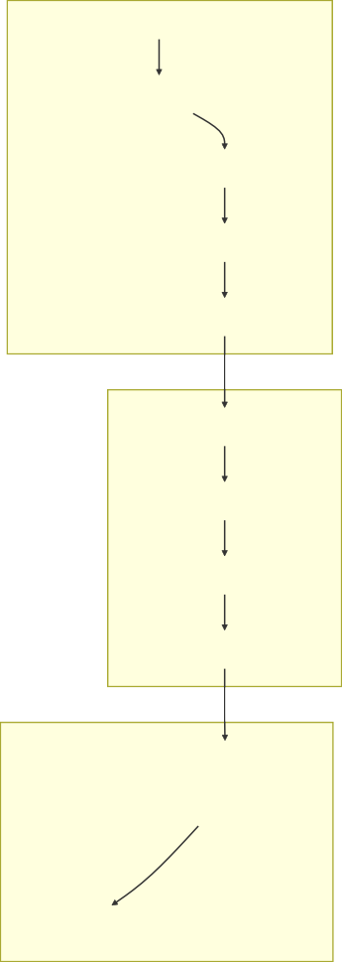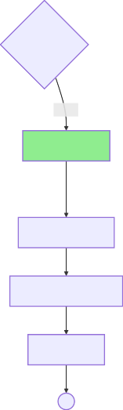
NEW
APPLICATION
○
SYSTEM INTEGRATION -
VERIFICATIO
Auto-Verified?
Mismatch Match
Auto-Verified
ISSUANCE

Enter in KIAMIS
Generate Farmer ID
Issue Card
●

Flag Mismatch

Auto-Capture GIS Data

Query Lands for Ownership

Query IPRS for Identity

Receive Application

Submit to County

Provide Land Reference

Provide ID Number

Complete Form

Removed Steps:

Attach ID → Provide ID Number only
Attach Land Documents → Query Lands system Verify Identity → IPRS auto-query
Verify Land → Lands auto-query Capture GIS Data → Auto from Lands

  - Export Permit (TO-BE)
Key Change: Trading license inheritance - no re-verification

FARMER LOOKUP - NEW
○
LICENSE CHEC
License Valid?
Yes
No
PROCESSIN
●
Submit via IMIS
Attach Contract
Upload Quality Certificate
APPLICATION
Link to Shipment
Transmit to Customs
Generate Permit
System Validates
Check Trading License Status
System Retrieves Farmer Details
Enter Farmer ID
Notify Exporter
Redirect to Trading License
License Valid

Removed Steps:

Complete Form → System pre-populates from Farmer ID Attach License → License checked from registry
Verify Trader → Auto from Farmer ID
Verify Origin → Auto from KIAMIS

  - Trading License (TO-BE)
Key Change: Auto business registry verification

APPLICATION
○
AUTO VERIFICATION -
DECISION
Decision?
Fai
ISSUANCE
●
Notify Applicant
Submit Report
Conduct Inspection
Schedule Premises Inspection
TION
INSPEC
Auto-Verify Registration
NEW
Query Business Registry
Submit Application
Provide Premises Details
Provide Business Registration No
Complete Form
Update Registry
Notify Failure
Generate License
Pass

Removed Steps:

Attach Business Registration → Provide Registration No only Review Documentation → Auto business registry query Assess Premises → Streamlined to inspection only

  - End-to-End AFA Services (TO-BE)

●
Export Facilitation
KENTRADE Integration
Permit Generated
Contract
Quality Cert
License Check
END-TO-END AFA SERVICES - TO-BE
Farmer ID Lookup
License Stored
Trading License
Auto-Verify
Lands Integration
Farmer Registration
○

Science, Research and Innovation (AS-IS = TO-BE)
Ministry: Ministry of Education
Department: State Department for Science, Research and Innovation

Assessment

Criteria | Finding
Current Process | Already streamlined
Integration Opportunities | Limited - research-specific
Automation Potential | Low - requires expert judgment
Recommendation | Maintain AS-IS

  - Research Application (TO-BE = AS-IS)
No Changes Required - Process already optimized


APPLICATION
○
Attach Documents
Submit Application
VERIFICATIO
Complete?
No
Yes
Return for Completion
Log in Register
ASSIGNMENT
●
Issue Acknowledgment
Assign to Examiner
Identify Examiner
Review Category
Assign Reference
Complete Application

  - End-to-End Research Application (TO-BE = AS-IS)

END-TO-END RESEARCH
APPLICATION
○
●

Agreement Signed

Proposal Developed

Payment Processed

Decision

Assessment

Assigned to Examiner

Logged

Application Received

Sports (AS-IS = TO-BE)
Ministry: Ministry of Youth Affairs, Creative Economy and Sports
Department: State Department for Sports

Assessment

Criteria | Finding
Current Process | Manual oversight appropriate
Integration Opportunities | Limited
Automation Potential | Low - requires human judgment
Recommendation | Maintain AS-IS

  - Federation Registration (TO-BE = AS-IS)
No Changes Required - Manual verification appropriate for governance


APPLICATION
○
VERIFICATIO
Complete?
No
Yes
ISSUANCE
●
Prepare Report
Verify Representation
Check Leadership
MEN
ASSESS
Verify Compliance
Return for Corrections
Submit Application
Complete Form
Update Registry
Issue Certificate
Approve
Review Documentation
Prepare Documents

  - Athlete Grant Application (TO-BE = AS-IS)
No Changes Required - Committee review appropriate for public funds

APPLICATION
○
VERIFICATIO
Registered?
Yes
ASSESSMEN
No
DISBURSEMEN
●
Submit to Committee
Prepare Assessment
Review Budget
Athlete Signs
Prepare Agreement
Assess Purpose
Submit
Attach Endorsement
Attach Records
Verify Registration
Complete Form
Process Payment
Reject Not Registered
Review Performance

  - End-to-End Sports Services (TO-BE = AS-IS)

END-TO-END SPORTS
SERVICES
○
●
Maintenance
Facility Booking
Competition Support
Grants
Talent Identification
Oversight
Federation Registration

Appendix A: Integration Points Summary

Integration | Source System | Target System | Data Exchanged
CRS Lookup | Children Services | Civil Registration | Child identity, birth records
IPRS Query | Multiple | IPRS | National ID verification
CRS Marriage | Civil Registration | CRS | Marriage records
Lands Query | AFA | Ministry of Lands | Land ownership, GIS data
KHIE Push | Health Facilities | KHIE | Encounter data, prescriptions
SHA Claims | KHIE | SHA | Claims data
KENTRADE | AFA | KENTRADE | Export permits
Business Registry | AFA | Business Registry | Company registration

Appendix B: Automation Summary

Process | Automation Type | Expected Benefit
Birth Registration | Auto-verification | 70% faster processing
Death Registration | Auto-lookup | Eliminated 2 attachments
KNQA Assessment | AI-assisted | Committee removed
Farmer Registration | Lands integration | Manual verification removed
Export Permit | License inheritance | Simplified workflow
Health Records | KHIE integration | Unified patient record

Appendix C: Document Summary

# | Ministry | Processes | Status
1 | Children Services | 3 | Modified - CRS integration
2 | Civil Registration | 4 | Modified - IPRS/CRS
3 | Health | 4 | Target State - KHIE/BHI
4 | Education KNQA | 4 | Modified - AI assessment
5 | AFA | 4 | Modified - Lands integration
6 | Science Innovation | 2 | AS-IS = TO-BE
7 | Sports | 3 | AS-IS = TO-BE
 | TOTAL | 24

Document Generated: February 2026
Government of Kenya - Business Process Re-engineering Initiative

